**7. Configure your modem/hotspot to operate only in 2.4Ghz and connect your laptop/Wi-Fi device, and capture the capability/properties in your Wi-Fi device. Repeat the same in 5Ghz and tabulate all the differences you observed during this.**

**Hotspot – 2.4Ghz**

Properties:

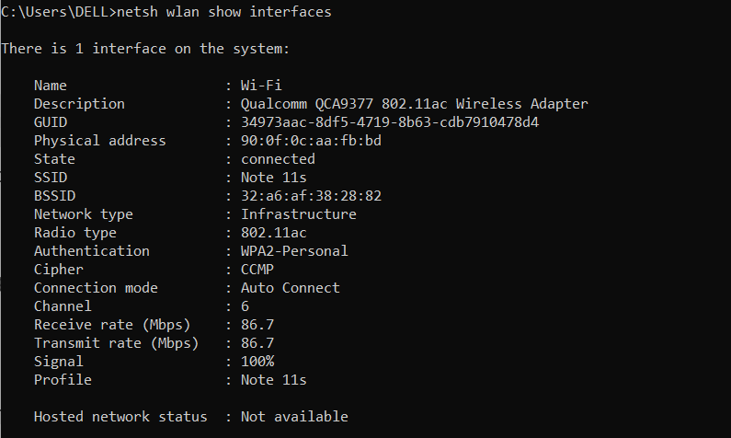

**Hotspot - 5Ghz**

Properties:

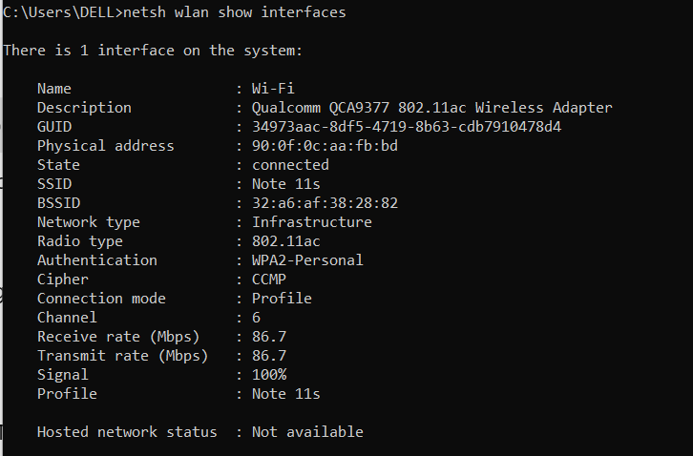

**Observations**

1. Same Channel Used (6)
2. Same Data Rates (86.7 Mbps)
3. Same Radio Type (802.11ac)
4. Connection Mode Difference
   * 2.4GHz: Auto Connect
   * 5GHz: Profile
   * This suggests manual connection was required for 5GHz, while 2.4GHz connected automatically.